Management Information and Enrolment System for Holy Cross College

J. M. A. Dimacali  
M. D. D. Galang  
C. J. G. Gubat  
N. N. Manalungsung

I. INTRODCUTION

With the help of technology, doing impossible things is now become possible in this modern world. Most of the people now is using technology for the fastest and easiest way of living. Computers seem to have played an important role in today’s generation it can help the persons working in company and it is also help the students for their school works with the help of internet all things that impossible would be possible.

Holy Cross College is the only school that has a college level in the Concepcion, Tarlac. The School is currently using a manual process in every of their transactions these are recorded manually. In line with this, the school population is getting bigger and does not limit their number of students per school year. With this big population it is difficult to manage the information of the students using their manual process these information, also be kept secured and safely. The process of their enrolment is also a manual.

The proponents will propose a management information and enrolment system which will help the school and the student to minimize the time they spending in the manual process that they are currently following. A management information and enrolment system, the system will lessen the paper works of the faculty because the manual writing of some forms will be computerized and the information of the students will be kept in database that is surely secured and safe. The system also provides an enrolment system for the students for they will not need to fall in line to be officially enrolled to the school.

II. PROJECT CONTEXT

The management information and enrolment system will easily record the student grades and schedules. This system will be a big help not just for the school but also for the students and teachers. The system has the capability to search, add accounts, add grades, and add schedules of students. It is intended to be used by five categories, the Admin, Principal, IT Head, Faculty and the Students.

For the past years, students of Holy Cross College are still using the traditional process of enrolment. This traditional method will be obsolete in a few years, because the live in modern times, where almost everything is digitized or computerized, recording with ink of paper also have problems, sometimes the word written are not visible or blurry, and the books may take a lot of space in the storage area. There are so many papers that are important, and maybe in the damaged by fire or flood. The proponents looked for a solution that can help the Holy Cross College on these problems: by creating a management information and enrolment system for holy cross college that will display the records of student grades, subjects, and schedules online. It will allow the students to access this website for them to make the process fast and easy. The system will provide an online enrolment for students, and by that, they can also pay their tuition fees using the online payment of the website. The system will provide an online payment for students, they can pay their tuition fees or enrolment fees using their debit cards or online account. The system has a database that is connected on cashier, for the security of the payments, students can choose if they will pay for partial or full payment.

When it comes to the technicality and to the developers of this system, the information is stored in the database Mysql, PHP, HTML, CSS and JavaScript will be used for the design and develop of the system. It is important to implement this system because it is not only for Holy Cross College but also to the other Schools.

III. PURPOSE AND DESCRIPTION

To the Holy Cross College, the system will benefit them in a way that their old process which includes paper and ink will be changed into computerized system. This will help the faculty in charge of recording the enrolling students to lessen their work time competing their task. And to lessen teacher’s work when it comes in recording of the grade of students. With this process, teachers will easily record the grade of students without the risk of data lost.

1. *For the Admin/Principal*

The proposed system can help the admin to manage the records of the students and teachers’ information. He/she can edit and update the students and teacher’s account. The admin will give an account to the teachers for the grading system.

1. *For the Faculty*

The proposed system will help the faculty to record and post of the students grades through online instead of giving the cards manually. The faculty will easily manage the students’ grades.

1. *For the Students*

It is good news for them because they will not fall in line and wait to be enrolled and they can easily view their grades and schedules through online by accessing the website.

1. *For the Locale*

The proposed system will help the locale to get an easier way in the transactions that they are doing in the school.

IV. OBJECTIVES

The Main Objectives of the study is to design develop a Management and Enrolment System with for Holy Cross College to convert their manual process into a computerized form.

Specifically, this study aims to achieve the following objectives:

1. To design and develop a Management Information and Enrolment System for Holy Cross College.
2. To create modules for the following:
   1. Admin/Principal
      1. View the student and teacher information
      2. View and update student and teacher account
      3. Account recovery for student and teacher
      4. Download and print list of teacher and student
      5. Online Enrolment Verification
   2. Faculty
      1. Student’s scheduling
      2. Student’s grading
      3. Official list
      4. Download and print student grades
   3. Students
      1. Online Registration
      2. Online Enrolment
      3. Online Payment
      4. Viewing of grades and schedules
      5. Edit Information
      6. Download and print assessment form
3. To evaluate the project
   1. Users
      1. Graphical User Interface
      2. Usability
      3. Ease of use
   2. IT Experts
      1. Database Design
      2. Functionality
      3. Security

V. SCOPE AND LIMITATION

The main focus of the project is to design and develop a Management Information and Enrolment System for Holy Cross College that will be used by the school to get their transactions to be easy and fast, also for the students to view their grades, subjects, and schedules. The system has a database that will keep the student’s and teacher’s information secured. The system provides an online enrolment for the students that will help them to be enrolled easy and fast, and also can provide an online payment, students can pay their enrolment fee or tuition fee through the system, and others will be in cashier. The system will need online accounts, credit cards, or debit cards for the use of online payment. This system will need id number to make sure that they are students of the Holy Cross College for the security of the system and also the school.

The limitations of the system; students, admin, and faculty cannot access the website without the internet, and for the students they cannot register without their student number or id number. The second years students are the users target of the enrolment system. The second years student only can access the online enrolment for testing purposes, and rest will be offline. The system is only for the college level students of Holy Cross College. The online enrolment is for regular students only; the irregular cannot access the online enrolment because of conflict schedules and failed subjects, and also online enrolment system is for two courses only and it will be the Associate in Computer Technology (ACT) and Computer Science (CS).

V. RELATED LITERATURE AND STUDIES

1. *Foreign Literature*

According to the article written by Blessing, O. Ogbuokiri and Monica, N. Agu et. al, “University Mobile Enrolment System: A Nigeria Perspective” (2015). Using mobile application system for enrolment of students will give them a definitely speed up university enrollment processes and it can reduce errors and it can increase efficiency whilst giving users the convenience use of the system. ICT is an indispensable tool in achieving enhanced learning environment. Using of mobile application is to give the student a support for where they can use on any internet access at anywhere and anytime. [1]

The said article states that using a mobile application system for enrolment of students in Nigeria will give them a truly speed in their university enrollment process which is really true and it will give them the efficiency of use. The only difference between the proponents’ study is that, our study is not mobile application and it has a Management Information System for students and teachers.

According to the article written by Benjamin Richard Lahue (2014). “Management Information System: an Information portal for Major limitless interpretations”. MIS or Management Information Systems is the people-oriented use of computers in business. And it is a both field of study and a career path. It said that the information gathered was used to generate the requirements for an information portal relating to the MIS program at the University of Northern Iowa (UNI). A portal is a one stop shop for the information, MIS and other tools relating to a specific topic. The primary purpose of this said information portal is to be a resource of information related to the MIS program at UNI or University of Northern Iowa. [2]

The article states that gathered information was used to generate the requirements for an information portal relating to the MIS program at the University of Northern Iowa (UNI). Using a Management information System is to records all information and it also produces regular reports on operations for every level of management in a company. The difference between the proponents’ study is that, the management information system has an enrollment system that can record student grades and schedules at the same time can manage student and faculty information.

According to Joshua Jamora (2013). “Enrollment System” of Colegio de Saint Monique is used for students records in school. Enrollment System can be useful to reduce the load of the people that normally has to do all the manual work. A well enrollment system is built for faster process information. [3]

The enrollment system is used to reduce the load of the human that normally has to do all manual work like in the enrollment process. Enrollment system build for a faster process and transactions for the enrollment. The difference between the proponents’ study is that, it is only for the second years student only and for two courses.

1. *Local Literature*

According to Alvin O. Abraham, Shayleen G. Bolos, and Patrick T. Martelino (2014). “Automated Grading System with Decision Support Mechanism for K-12 Based Teachers of Sta. Ignacia Academy” This system will help the Sta. Ignacia Academy in providing a secured and user-friendly system for computing, storing, and managing of student grades. This system is automatically computing the grades of students they will not need to write it. [4]

This system aids teachers in computing and storing the grades of the students, and to maintain the security in managing grades of the students. The difference between the proponents’ study is that, the proponents study is not automated it will just input the final grades of the students.

According to the article of Balatbat, P.C.D et. al (2013). “Online Information Management System” This is used to help teachers and also students to have easier way in gathering quarterly student’s data. This system also provided an online portal for the parents to easily monitor their children’s performance in school. Both students and parents will easily view the records by accessing the system. [5]

This system is focused in monitoring of student’s and teacher’s data. And it also has a portal for parents so that they can monitor their children’s performance in school. The difference between the proponents’ study is that, not only management information system but also have an Online Enrolment System.

According to the article of Pressman et. al (2013). The web has become, and indispensable technology for business, communication, media, and transportation to name just few areas that impact your life. It has changed the way in which the people buy products, meet people, voice our opinion, entertain ourselves, and go to school.

The proponents learned from this article about the advantage of website in different part of our lives. It can proactively interact with users and processes their tasks efficiently, in business, communication, education, media, and transportation. The difference between the proponent’s study is that, the website is for the students and teachers of Holy Cross College, not for everyone. [6]

1. *Foreign Studies*

According to Christian Le Marjo A. Caipang (2013). "Development of a Computerized Enrolment System in a Rural-based Higher Education System". The purposed of this system is to create an Online Enrolment, the main focus to is to help students, faculty, and staffs of the school. Students can use the system to enroll at their school and to make the process easy, they can simply enroll at their home. The system also has a management information system, to find the records the records of the students. [7]

This system will make the transactions of the school easy and fast, students can easily enroll at the school. The paper works will be computerized, and by that students will minimize their time. The difference between the proponents’ study is that, it has also the online payment and by that they can pay their tuition fees or enrolment fees in the system by using online accounts.

According to the article of Rowena A. Decena and Fe Sharon C. Tubal (2015). "Fractal Grading System and Its use in the Philippines" This grading system is defined as the method utilized in measuring the student's typical performance in order to come up with his/her final mark. The purpose of this study is to transfer the grades or scores in the system, and by that, parents of the students will easily view and monitor their children performance by accessing the system. [8]

This system has a grading system which will help the teachers to lessen their works, students can view their grades at the system. The difference between the proponents’ study is that, the final grade only will be posted at the system.

According to Pearl Jean et. al (2016). "A Proposed Computerized Enrollment System for Western Visayas Sanitarium Elementary School". The system or the computerized system helps enrollees and transferees enroll in a much faster and innovate way, which point more towards on the new students and transferees. [9]

Enrolment System will be computerized not manual or paper works, system helps students to make the process easy and fast. The difference between the proponents’ study is that, transferees cannot access the management information and enrolment system because only regular students will be accepted on the system, and only second years students, and two courses only can access the enrolment system.

1. *Local Studies*

From the study of Darupe, Sherwin Joelle, Escleto Carl Glenn, Lagman John Martine, Villanueva John Clyde, and Yanga Jeffrey et. al. (2013) “Web-based Faculty Evaluation with Grading System of St. Vincent School Foundation INC. for High School Department”. This will benefit the teachers to make the process of grading system will be easy by using this system. This study will help the teachers to enhance teaching skills by using output evaluation. [10]

This project can reduce time and effort instead of using papers, it will also help the teachers to compute the grades of their students faster. The difference of the proponents’ study is that, our study does not have an evaluation for the teachers.

From the study of Querido, Angelica Tagama, Angeles, Wendy Hipolito, Capilo, Joel Navarro, Galleon, Precious Joy Domingo (2015) “Online Management System for Student Development Office” This study is to help TSU-Student Development Office to integrate new technology in their pursuit to better manage their files, and also to make it computerized. To make it safety, they created a system for the school. [11]

This study is a system for record keeping and management of profile and membership of the Student 'Development Office (SDO). The difference of the proponents’ study is that, the management information system is not only for students but also for the teachers.

From the study of Rosemarie R. Sabado, Edzel T. Bernabe, Alfred C. Pacubas, Mark Jayson A. Magday (2015) “Online Records Management Information System (ORMIS) for Bureau of Fire Protection Tarlac Province”. This study will help and provide assistance to the administrator and employees of Bureau of Fire Protection Tarlac Province in terms of report update, to modify the main administrator for the reports that is being sent or updated by each municipality. The Reports are stored at the system’s database so that they can easily access their files when needed. [12]

This study is a record management information system that can update and modify reports by Bureau of Fire Protection Tarlac Province employees and administrator. The difference of the proponents’ study is that, the admin can edit, and update online.

1. *Conceptual Framework*

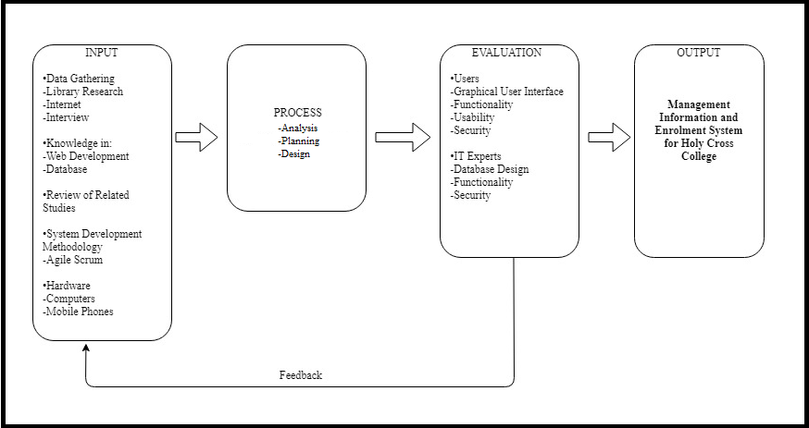  
FIGURE 1.0 CONCEPTUAL FRAMEWORK

Figure 1.0 illustrates the conceptual framework of the established model of the concept study. The Concept framework is composed of input, process, output. Input phase consist of data gathering, wherein the proponents gather relevant data and related information for the study, input phase also contains the knowledge in Hardware and Software. After the gathering of data, the process phase 3 which includes the analysis of the gathered data; planning stage where the researcher formulated possible solution for the problem of the chosen local. The system is evaluated by IT experts, administrator, and user for the feedback and modification of the system. After gathering the feedback, the developed system goes back to the data gathering for the modification.

VII. RESEARCH DESIGN AND METHODOLOGY

This section presents the methodology that was employed by the researchers in conducting the study. It would explain the different methods of research used, data gathering instruments, research design and the detailed procedure in the development of this concept system.

1. *Data Gathering Tools*

*Library:* In this data gathering tool, it is the best way and the most useful way of searching data and information, and it is contains knowledge and information that are related to the study. In this method it will helps the proponents to advocate the gathered data and information in the library of *Tarlac State University in San Isidro Campus* to ensure the reliability of the information used.

*Internet:* The internet is also the most useful tool on getting ideas and inspiration by only searching in the web. In this modern times internet also becomes more popular when knowing the latest updates and information that has happening now in our society. Getting assistance and help in the study of the proponents, the internet can give that especially when they are searching information regarding on local and foreign studies, articles, and the application that related in the study. The proponents believed that in this method using different sites will create a successful and reliable system. That’s why the proponents use this tool for the additional knowledge and improvements of their study.

*A.1 Data Gathering Techniques*

*Observation:* The proponents used observation as a technique on observing the locale on how they process on their organization. Observing the needs and problems of the locale and to determine the problems being encountered, and proved that there was a real needs and problems on the locale to be able to the proponents to work for.

*Interview:* The proponents have conducted an interview on the IT Head and Principal of the locale to verify the problems and needs and also the information being used in the study.

*Consultation:* The proponents consulted some IT experts who have the knowledge about the project and regarding on the development of the software and also the progress of the study with the help of the Capstone Technical Adviser and the Capstone Subject teacher.

*Internet Surfing:* The researchers gathered information using the internet related to the proposed system. The proponents use the internet as a tool to search for related literatures and studies that will be used for benchmarking.

1. *Proponents Locale*

The Concepcion Holy Cross College is located in Concepcion, Province of Tarlac. Concepcion Holy Cross College or CHCC is the only school that has a college level in Concepcion. CHCC has offering best course that the future students can enroll these are BS Criminology, BS Education that has five majors Math, English, Filipino, MAPEH, and Social science, BS Computer Science, ACT, and BS HRM.

1. *System Development Methodology*

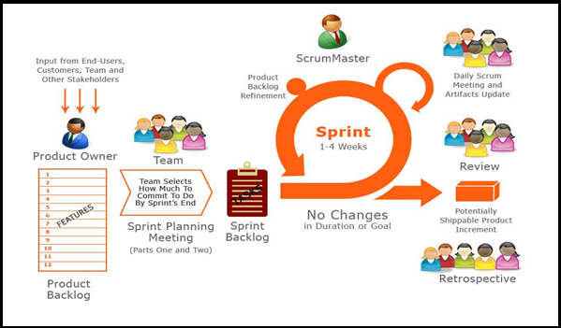

FIGURE 3.0 AGILE-SCRUM METHODOLOGY CYCLE

Figure 3.0 shows the Agile Scrum Methodology Cycle. The proponents will be using the Agile Scrum development all throughout the development of the proposed project. The said methodology is an iterative and incremental agile software development framework for managing software projects and product or application development. This method is iterative and incremental for managing projects or application development. Also this method is flexible enough that it can managed changes easily.

The proponents start on their process of interviewing the locale for the needed requirements and design, and then the product backlog was composed. This product backlog was refers’ to the collections of user stories. And when the product backlog was created the plans for the implementation occurs, once all of this are implemented the proponents would identify the sprint of the product backlog. The sprints are the schedules that are needed for implementing the backlog.

This methodology was helped the proponents on developing their study in an efficient and effective way. The proponents saw that the system was have a real need on making changes, includes that how the interface looks regarding on the suggestions of the locale.

*Planning*

In this phase, the proponents used to identify the problems of the locale that has encountered and in the creation of solutions to solve the problems.

*Scrum*

During the process of developing the study, the proponents conducted a meeting that lasted for 20-30 minutes. To discuss the development process of the study and it also helps the proponents to plan another task needed to accomplish according to the product backlog.

1. *Sampling Technique and Population*

As stated by social research method, net sampling is the process of selecting units (e.g people or organization) from a population of interest so that studying the sample we may fairly generalize our result back to the population from what will they chosen.

*Population of the Study*

The Holy Cross College has a total of six hundred eighty three (683) students, the males are three hundred five (305) and the females are three hundred seventy eight (378), and a total of thirty five (35) Professors/Teachers in college level.

1. *Operational Feasibility*

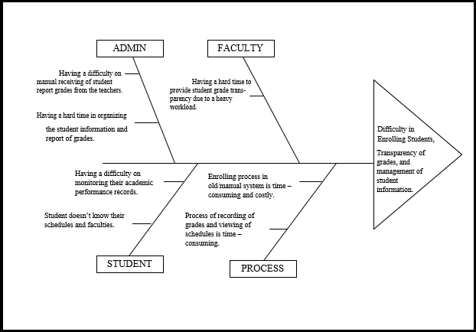

FIGURE 2.0 FISHBONE DIAGRAM

The figure shows the problem of the locale regarding their existing system. This figure shows the problems of the locale regarding with the management of student information, grade transparency and the manual enrollment process of the college. The admin having a trouble on manual receiving of student report grades regards to the manual system, and having a hard time in organizing the student information and report of grades. The faculty having also a hard time on providing the student grade transparency regards to a heavy workload school works. The students want to know their schedules and their grade on just browsing on one system. Also, the Students having a difficulty on monitoring their academic performance records. Process of recording of grades and viewing of schedules is time – consuming, and the enrolment process in Concepcion Holy Cross College is in manual system and this will cause in a time - consuming process.

1. *Technical Feasibility*

The Holy Cross College is one of the leading private schools here in the Philippines and specially here in Tarlac that has a computer laboratory with a switches and router per year level waiting to be connected. By this, the resources that the proponents might need in pursuing the study are currently available. The school will no longer burden in injecting the development system because of the availability of the resources. The proponents also conducted an interview, and observation to have deep understanding of the current enrollment process of the said school and come up in designing a system that will serve as their tool to make all work for a minimal time. A private school that has a computerized enrollment system will gain such edge because of the satisfactory result of every transaction made. With this, there will be no longer use of encoder that must submit encoded master list and summary report of all students who enrolled. The said school will know for its reliable and accurate source of information. The satisfaction also takes place for those who assess student not only during the enrollment but also for the long use of saved data for future use. The purpose of this study is to fulfill an effective and efficient system that will serve as a more reliable tool in monitoring and enrolling students in the said school.

1. *Economic Feasibility*

The faculty and students of Holy Cross College will benefit to the said study. The teacher will get their benefit depending of what transaction they need to do. If the Principal, Department head and or guidance officer needs a certain report they just have to log in for them to access the system manipulate it produce report according to what they need. They do not have to go to every year level and different kind of office inside the said school when the only thing they to do is log in and the system is ready to serve its user for the necessary requirements they need to submit. The printed output is informative. The said system will provide the expected output of the user. The system will transform the conventional way of record keeping to an organized inside the school.

1. *Statistical Treatment*

The researchers provide a set of questions for people always riding a regular bus and conductors as well as the IT professionals whom will conduct the evaluation for the system’s functionality and graphical user interface by analyzing, classifying and tabulating. The researchers used weighted formula to determine the responses of the users. The results of the data are weighted by mean to analyze the gathered facts based in questionnaires to determine the weaknesses of the proposed project system and the level of accuracy.

|  |  |  |
| --- | --- | --- |
| **Rating** | **Average Mean** | **Descriptive Rating** |
| 5 | 4.26 - 5.00 | Excellent |
| 4 | 3.26 - 4.25 | Very Satisfactory |
| 3 | 2.26 - 3.25 | Satisfactory |
| 2 | 1.26 - 2.25 | Fair |
| 1 | 0 - 1.25 | Poor |

This table shows the scaling system will be used by the proponents to evaluate the proposed system entitled “Management Information and Enrolment System for Holy Cross College”.

This table shows the ratings, average mean and the descriptive ratings, wherein it will be used to specify the given data from the evaluation result. An average mean is equivalent in the descriptive rating that is set. 5 will be the highest possible rating and 1 will be the lowest possible rating. The feedbacks and responses will be summarized using the weighted mean formula below.

Grand Mean= (*x*f)*

*N*

Weighted Mean = *(5*f + (4*f) + (3*f) + (2*f) + (1*f)*

*∑N*

Where x – number of rating

F – Frequency of particular respondent

N – Total number of respondent

Where ∑ = summation, f = frequency of a particular respondents, N = total number of respondents.

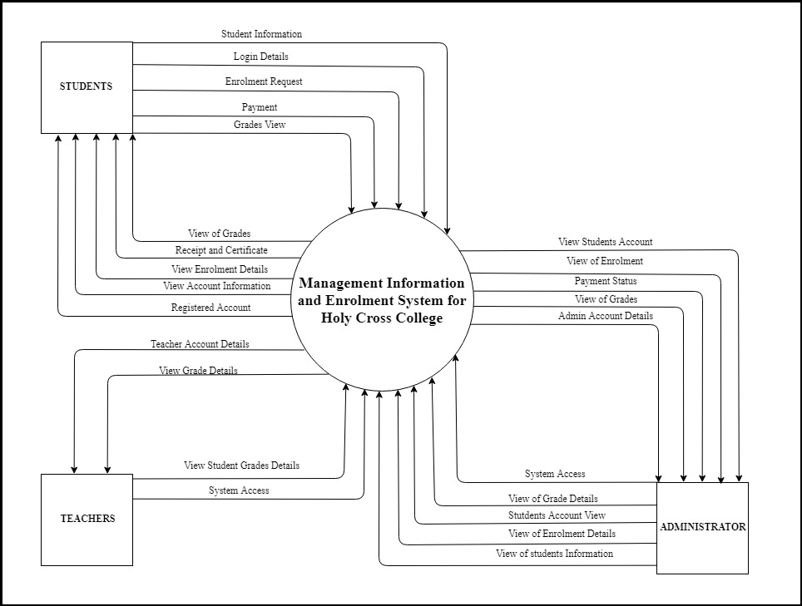

FIGURE 4.0 CONTEXT DIAGRAM

Figure 4.0 shows the context diagram of the proposed system. By inputting the student’s personal information in the registration form of the proposed system, the student will have his/her account. And after the student’s registration, he/she can now login to his/her account to view the account information. The student will request an enrolment to view the enrolment details. For the student he/she can view his/her grades in the proposed system.

The teacher should sign in to his/her account to access the system, he/she can view his/her account details. For the teacher he/she can view the student grades details.

The admin should sign in to his/her account to access the system. The admin can view his/her account details. The admin can view the grades details of the student. For the admin, he/she can view the students account. The admin can view the enrolment details, he/she can also view the payment status of the student. For the admin, he/she can also view the students information.

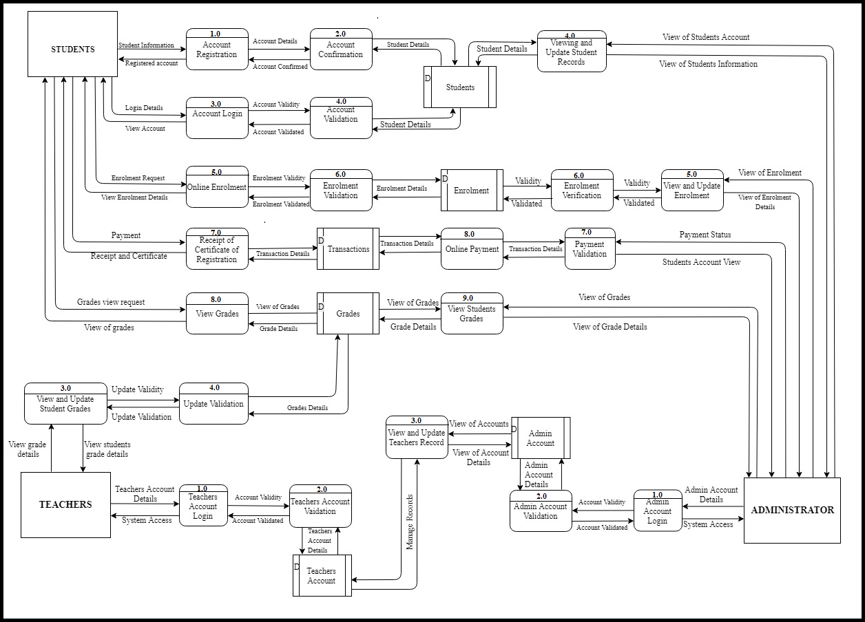

FIGURE 5.0 DATA FLOW DIAGRAM

Figure 5.0 shows the data flow diagram of the Management Information and Enrolment System. The student will provide their information for the creation of account. The account details will be confirmed for the registration of the student account. For the student to log in, he/she will input the log in details. The details will then be validated for the student to view his/her account. The student can request an enrolment and it will be validated for the enrolment. The student can also view the transactions of his/her payment, receipt, and the certificate of registration. For the student, he/she can request to view his/her grades.

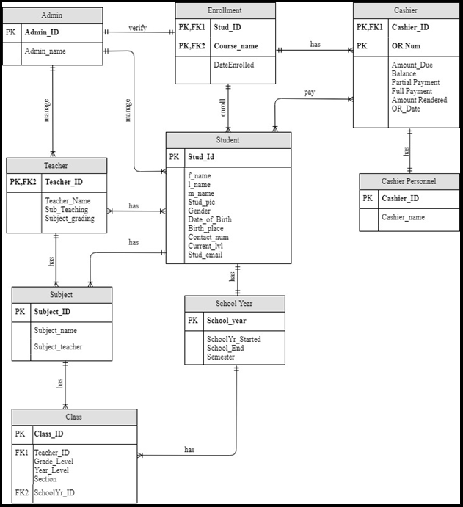

FIGURE 6.0 ENTITY RELATIONSHIP DIAGRAM

Figure 6.0 This diagram shows the Admin table has a one to one relationship to enrollment table. One row in the Admin table is connected to a row in the Teacher table and Student table. The Admin can manage the students and teacher information that is why the Admin table, Student table, Teacher table has one to many relationships. Whenever the student enrolls a course data will be inserted in the cashier table and that explains the one to many relationship of enrollment table and cashier table. The teacher can view and manage his/her student, subject, and class that is why teacher table, subject table, class table has one to many relationships.

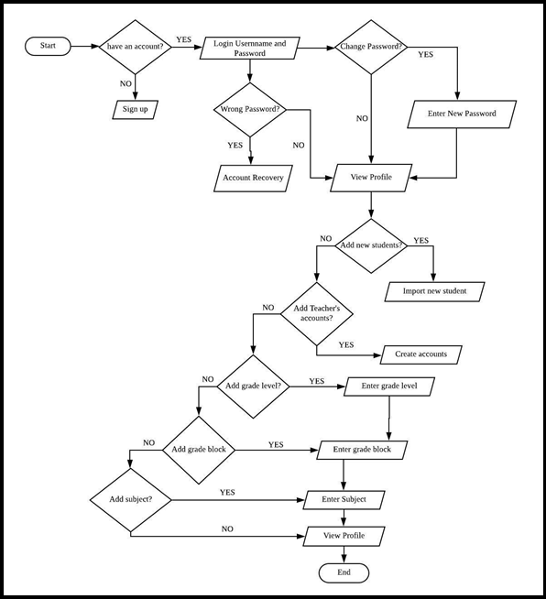

FIGURE 7.0 ADMIN/PRINCIPAL FLOWCHART

Figure 7.0 shows the process of the admin. Admin must change the default password that was given by the system. The admin must also add students to be able to import their grades and edit or update their information. The admin could add or create grade block or sections, grade level, subjects, account for the faculty of Holy Cross College. The admin is responsible for adding or creating of these modules to be able to login faculty and students in the study. The admin was also responsible for managing the enrolment system, enrolling the students to be able to enrolled the students.

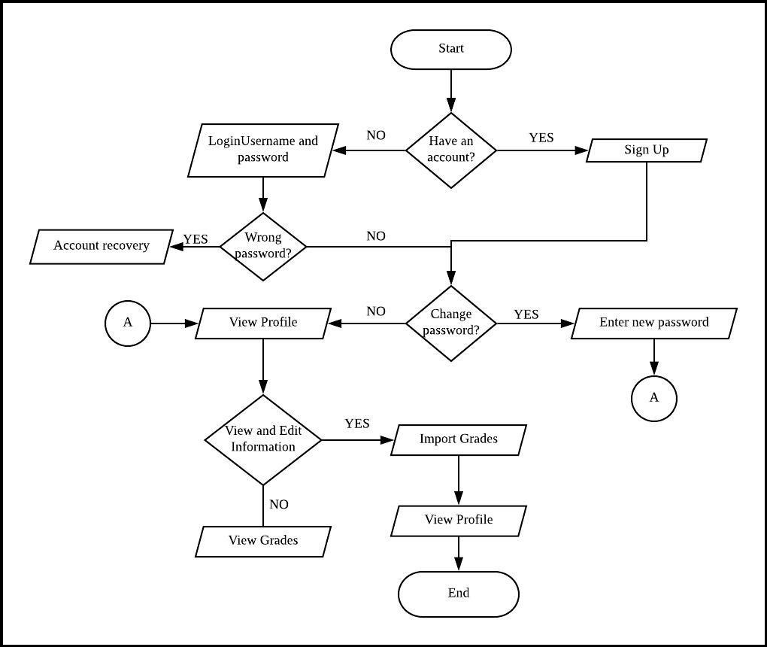

FIGURE 8.0 ADVISER/SUBJECT TEACHER FLOWCHART

Figure 8.0 shows the process wherein the adviser and subject teacher are responsible for inputting grades of the students. Adviser and subject teacher have the same function of editing of information and importing grades but when it comes to exporting grades, only the adviser could do such functions.

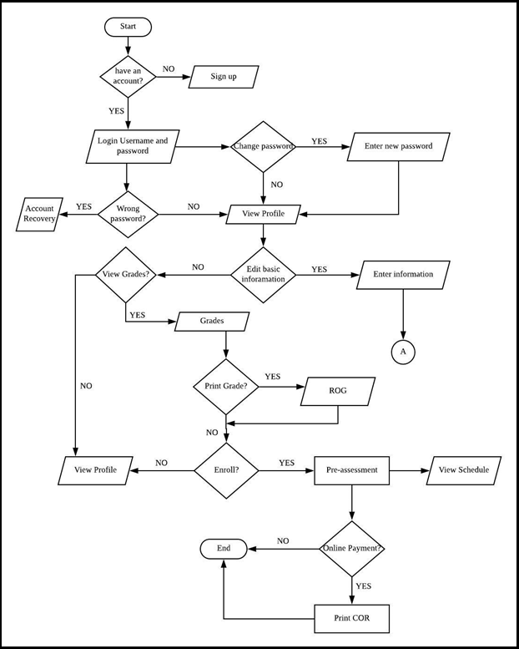FIGURE 9.0 STUDENT FLOWCHART

Figure 9.0 this is how the process of the students wherein they are capable of changing the default passwords given to them by the system, edit or update their information, and print out their report of grades(ROG). The new password must be a minimum of 8 characters, and it contains alphanumeric databases. When it comes to enrollment student can get their pre - assessment when they are done enrolling and they can choose whether the they want to pay online or in a manual way and then they can print their Certificate of Registration(COR) and they can also view their schedule online.

REFERENCES

Internet

[1] Blessing O. Ogbuokiri and Monica N. Agu “University Mobile Enrolment: A Nigeria Perspective” (2015). Available: https://www.researchgate.net/publication/289175483_University_Mobile_Enrollment_System_A_Nigeria_Perspective

[2] Benjamin Richard Lahue “Management Information System: an information portal for a major with limitless interpretations” (2014) Available: <https://scholarworks.uni.edu/hpt/148>

[3] Joshua Jamora (2013). “Enrollment System” of Colegio de Saint Monique. Available: Enrollment-System-1405014.html

Published Materials

[4] Alvin O. Abraham, Shayleen G. Bolos, and Patrick T. Martelino (2014). Automated Grading System with Decision Support Mechanism for K-12 Based Teachers of Sta. Ignacia Academy”

[5] Balatbat, P.C.D et. al (2013). “Online Information Management System”

Internet

[6] Pressman et. al (2013) Available: <https://www.ncbi.nlm.nih.gov/pmc/articles/PMC4267914/>

[7] Christian Le Marjo A. Caipang (2013). "Development of a Computerized Enrolment System in a Rural-based Higher Education System". Available: <https://www.researchgate.net>

[8] Rowena A. Decena and Fe Sharon C. Tubal (2015). "Fractal Grading System and Its use in the Philippines" Available: https://www.nmsc.edu.ph

[9] Pearl Jean et. al (2016). " A Proposed Computerizes Enrollment System for Western Visayas Sanitarium Elementary School". Available: https://prezi.com/ky469pwgmfjf/a-proposed-computerized-enrollment-system-for/

Published Materials

[10] Darupe, Sherwin Joelle, Escleto Carl Glenn, Lagman John Martine, Villanueva John Clyde, and Yanga Jeffrey et. al. (2013) “Web-based Faculty Evaluation with Grading System of St. Vincent School Foundation INC. for High School Department”.

[11] Querido, Angelica Tagama, Angeles, Wendy Hipolito, Capilo, Joel Navarro, Galleon, Precious Joy Domingo (2015) “Online Management System for Student Development Office”.

[12] of Rosemarie R. Sabado, Edzel T. Bernabe, Alfred C. Pacubas, Mark Jayson A. Magday (2015) “Online Records Management Information System (ORMIS) for Bureau of Fire Protection Tarlac Province”.